Banned/Challenged Book List

Cast, P. C., and Kristin Cast

The House of Night series
St. Martin’s Press
Challenged at the Austin Memorial Library in Cleveland, Tex. (2014), along with other young adult books that have a vampire theme. A local minister requested that the “occultic (sic) and demonic room be shut down, and these books be purged from the shelves, and that public funds would no longer be used to purchase such material, or at least require parents to check them out for their children.”
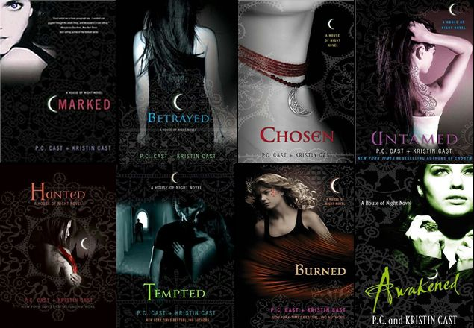
Source: AL Direct, August 27, 2014.

DeClements, Barthe

Sixth Grade Can Really Kill You
Viking Kestrel
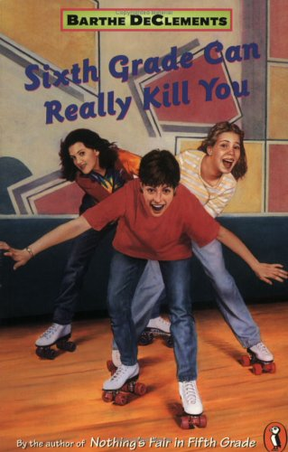
Challenged by a parent in Rosemount-Apple Valley-Eagan, Minn., elementary school libraries (2014) because it uses the “r-word” (retarded) to refer to students with special needs.

Geisel, Theodor Seuss

Hop on Pop: The Simplest Seuss for Youngest Use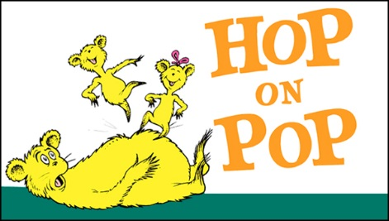
Random House
Challenged, but retained at the Toronto, Canada, Public Library (2014) despite a patron’s concern that the book “encourages children to use violence against their fathers.” The patron requested that the library apologize to local fathers and pay damages resulting from the book’s message. Written in 1963, the classic children’s picture book ranked sixteenth on Publishers Weekly's 2001 list of the all-time best-selling hardcover books for children. Based on a 2007 online poll, the National Education Association named the book one of its “Teachers’ Top 100 Books for Children.”

Geisel, Theodor Seuss

If I Ran the Zoo
Random House
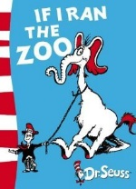
Challenged, but retained at the Vancouver, Canada, Public Library (2014) despite a line in the poem about helpers who “all wear their eyes at a slant,” accompanied by illustrations that are racial stereotypes of Asians. The book is often credited with the first printed modern English use of the word “nerd” in a sentence. The library will no longer read it at storytime or promote it other than as resource material in a study of how the portrayal of other cultures has changed over time.

Green, John

The Fault in Our Stars
Dutton Books
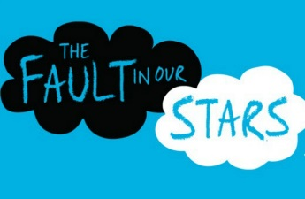
Pulled from library shelves at the Frank Augustus Miller Middle School in Rancho Cucamonga, Calif. (2014), because the subject matter involves teens dying of cancer who use crude language and have sex. Removed from the Riverside, Calif., Unified School District middle schools (2014) after a parent complained the teen love story was inappropriate for that age group. The New York Times best seller was released in June 2014 as a PG-13 movie. In 2014 Green was included in Time magazine’s list of the 100 most influential people in the world.

Green, John

Looking for Alaska
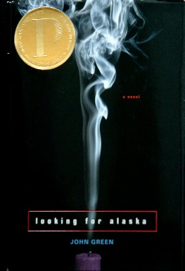
Dutton Books
Challenged, but retained in the Waukesha, Wis., South High School (2014) despite claims the book is “too racy to read.” Awarded the 2006 Michael L. Printz Award for Excellence in Young Adult Literature, this coming-of-age story traces the journey of Miles Halter, a misfit Florida teenager who leaves the safety of home for a boarding school in Alabama and a chance to explore the “Great Perhaps.”

Hosseini, Khaled

The Kite Runner
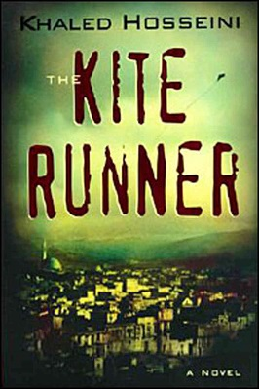
Bloomsbury
Challenged, but retained as part of the Waukesha, Wis., West High School curriculum (2014) despite claims the book “desensitizes students to violence.” The New York Times best seller is set against a backdrop of tumultuous events, from the fall of Afghanistan's monarchy through the Soviet military intervention, the exodus of refugees to Pakistan and the United States, and the rise of the Taliban regime. A number of adaptations were created following publication, including several stage performances and a graphic novel. The film of the same name was nominated for the Golden Globe Award for Best Foreign Literature Film in 2007.

Meyer, Stephanie

Twilight series
Little, Brown and Company
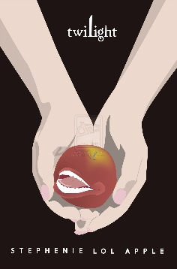
Challenged at the Austin Memorial Library in Cleveland, Tex. (2014), along with other young adult books that have a vampire theme. A local minister requested that the, “occultic (sic) and demonic room be shut down, and these books be purged from the shelves, and that public funds would no longer be used to purchase such material, or at least require parents to check them out for their children

Walls, Jeannette

The Glass Castle: A Memoir
Scribner
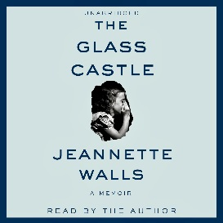
Suspended from the Highland Park, Tex., Independent School District’s approved book list (2014) by the school superintendent. The decision sparked a backlash and drew national attention. The superintendent then reinstated the book. In February 2015, the school district trustees approved policy changes on how the district selects books and handles parents’ objections. The challenged memoir is about growing up in poverty with a father who spent his money on alcohol and a mother who became homeless.

Winnie-the-Pooh
A.A. Milne
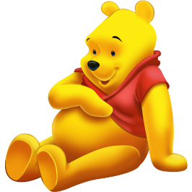
Winnie-the-Pooh has been introduced and reintroduced to generation after generation as a model of a child’s best friend. If you ask most people who their favorite silly old bear is, they’ll probably tell you that it’s Pooh bear. However, not everyone has found Pooh’s “rumbly tumbly” and honey obsession so endearing. According to Banned Books Awareness, this classic has been banned in a variety of countries at one point or another, including Russia, China, Turkey, and even its home turf, England. In fact, even some places in the United States have banned this book!
So why would anyone ever want to keep children from the joy of Milne’s classic? In the case of Russia, Winnie-the-Pooh was banned in 2009 because of alleged Nazi ties. In truth, the entire ban was based on the fact that a single person, known for supporting the Nazi party, was found to own a picture of a swastika-adorned Pooh. Apparently, this one isolated case is enough for Russia to decide that Winnie the Pooh is pro-Nazi, and therefore anti-Russia. In fact, if you investigate any of the claims or reasons of schools or governments for banning this book, you’ll find them to be silly and utterly absurd. As Pooh might say: “oh bother”.
Charlotte’s Web
E.B. White
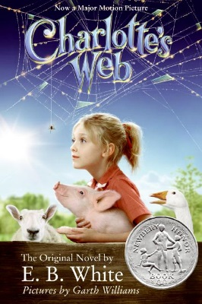
White’s heartfelt tale of the relationship between two unexpected creatures, a spider and pig, has been drawing children in for over half a century. Published in 1952, this classic has been readily available on most library shelves for children to read. However, some people would much rather that this title never see the light of day.In one extreme case, a school in England banned Charlotte’s Web for fear that the pig Wilbur might be offensive to Muslim students. Fortunately, the Muslim Council of Britain saw the folly of this ban: the book, and all other pig books, were quickly restored to their rightful place on the shelves.

Bridge to Terabithia
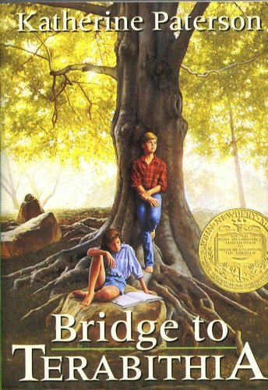
This classic title is number nine on the American Library Association’s list of most commonly banned books in the 90’s. The complaints have been many, though perhaps the most commonly contested aspect is the book’s portrayal of death. While some people applaud Patterson for crafting a story full of both fantasy and realism, others find the very real depiction of the death of a child to be too much for children to handle. Aside from the alleged morbid elements of this tale, Bridge to Terebithia has also been accused of promoting a variety of religious philosophies, including Satanism, Occultism, and New Age religion.

Where the Wild Things Are
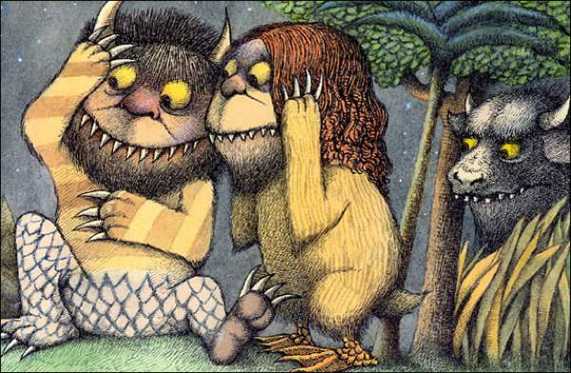
This classic, published in 1963, was adapted into a trippy, live-action film in 2009. Though it’s been around for over forty years, this book hasn’t always been readily available in libraries and in stores. After its release, Where the Wild Things Are was banned in libraries all across the U.S. for its dark tone and unruly lead character. Some parents were apparently uneasy about the fact that Max, the story’s protagonist, acted far too much like a regular little boy – he was loud, chaotic, prone to tantrums, and full of mischief. Nowadays, you’ll find far fewer libraries that still hold this ban, though some censors have stuck to their guns. Said censors have clearly lacked the desire to become kings or queens of their Wild Things.

